CERTIFICATE OF SERVICE

I hereby certify that a true copy of the Keeper of Records Notice of Taking Deposition and Subpoena were served upon the attorney(s) of record for each other party by mail/hand on .

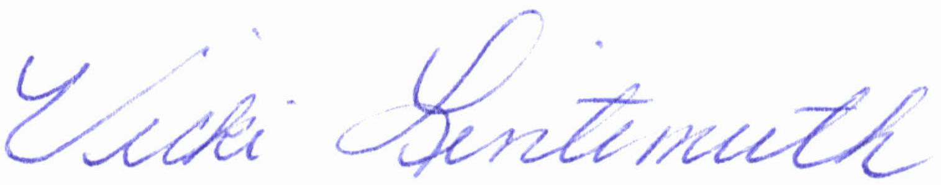

_____________________________________________
Vicki Lintemuth, Account Executive
Axiom Requisition Copy Service
447 North Canal Road
Lansing, MI 48917
(877) 886-5090
Dated:

Order No.: 01-16483-006

